**Laboratory Session 2**

**Testing and Branching**

1. **MIPS assembler directives**
2. **Pseudo-instructions**

The real instructions work of “li $t0, -5”:

**lui $1, -1**

**ori $8, $1, -5**

The real instructions work of “li $t0, 0xaabbccdd”:

**lui $1, -21829**

**ori $8, $1, -13091**

1. **Branching**

**3.1**

The secret number is: 506 (0x1FA)

**3.2**

I suppose that deleting “jr $ra” in the WIN label can run the LOSE label after the WIN label.

**3.3**

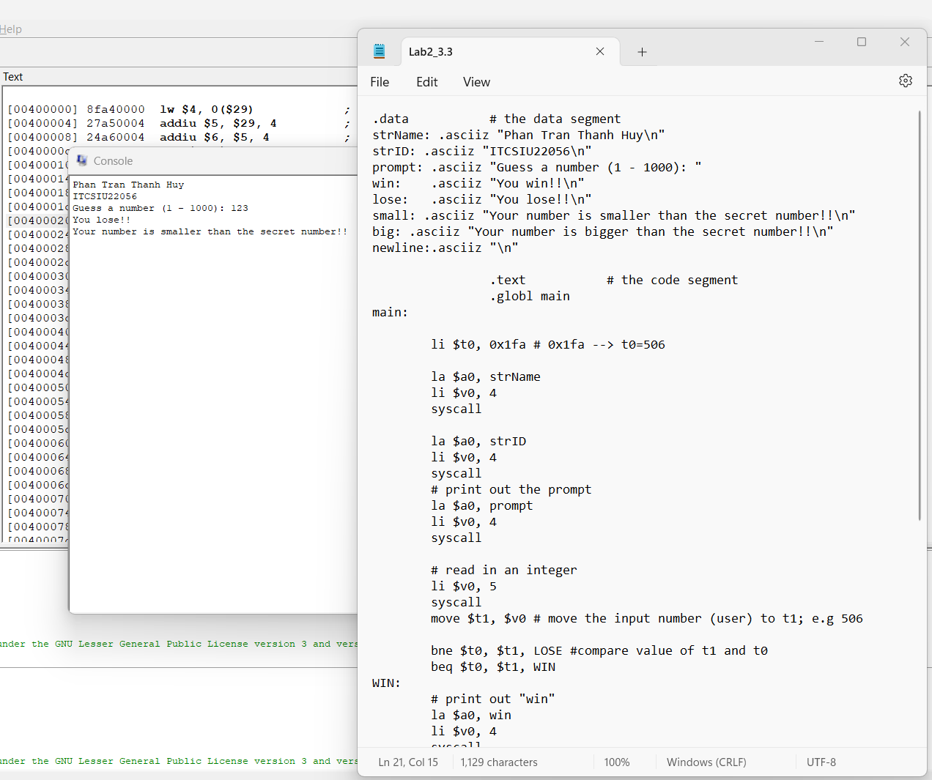

**3.4**

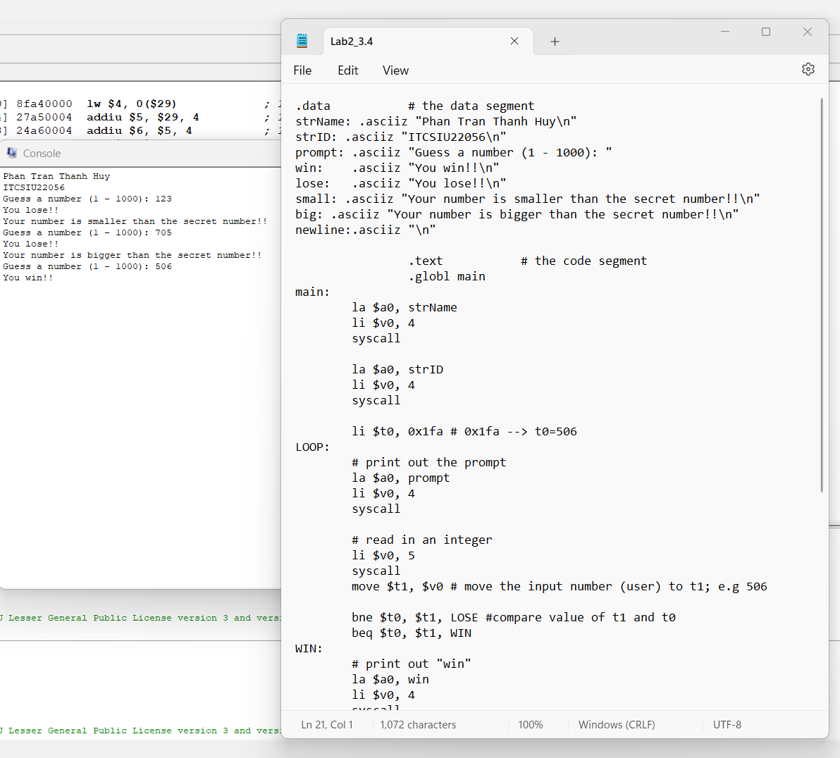

**3.5**

‘0’ is the **flag** character.

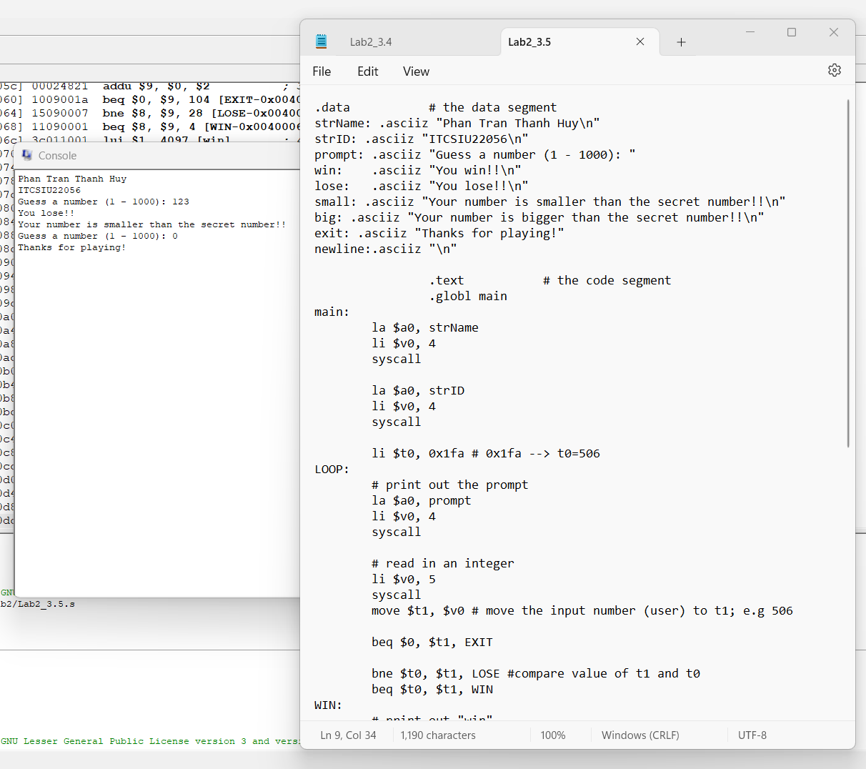

1. **String**

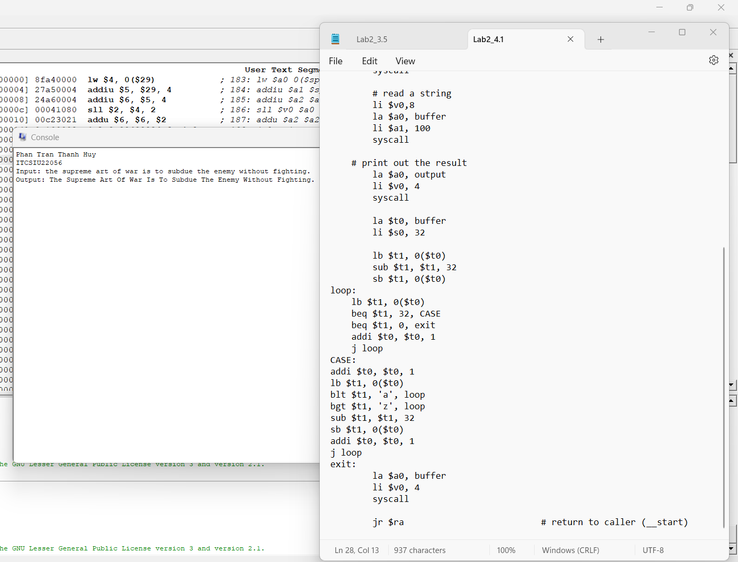



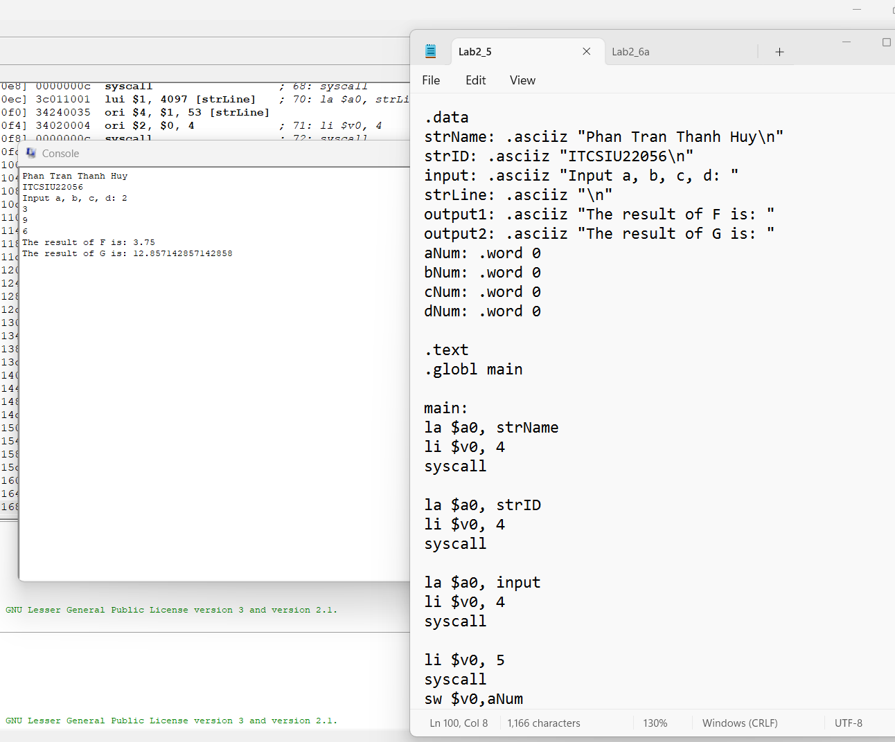

**6.**

**a/**

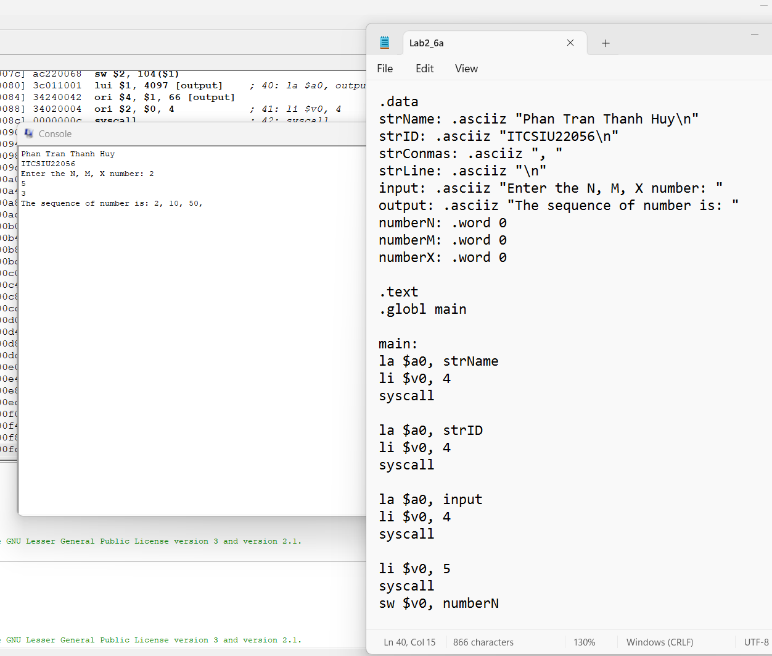

**b/**

